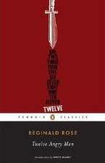Twelve Angry Men Summative Activity

Task: You will select a famous trial from the past and conduct various research in regards to the evidence used in the trial. From this research you will complete a summative:
- You will compose a five-paragraph persuasive essay based on perceived guilt or innocence (first completing an organizer that outlines your evidence);
Or
- You will then turn that evidence and essay arguments into a verbal presentation for the class. You may choose to explore either a digital reel using an interactive slideshow application on the Internet, such as PowerPoint, Prezi or VuVox, or an interactive timeline application using Dipity.

Purpose: To argue a specified point of view incorporating evidentiary support from a trial that you research. In this case, your thesis will argue whether or not the accused person is guilty or not guilty based on the evidence presented.

Where do I begin?
- Select a famous trial from the list below
- Using general reference materials, complete an initial graphic organizer that outlines the main facts of the case (page 7)
- Conduct further research and take more detailed notes on the evidence presented at the trial
- Determine your thesis based on the evidence and arguments presented: guilty or not guilty
- Select THREE subtopics to explore that will enhance your argument
- Select THREE pieces of evidence for EACH subtopic to use as supports
- Follow the essay template to organize your arguments for your five-paragraph essay
- Compose a rough draft of your essay
- Complete a peer edit checklist
- Incorporate your evidence and argument into a short verbal presentation using a web
  - application, selecting one of the following:

    - A digital reel using an interactive slideshow application on the Internet, such as
Prezi or VuVox;

OR
    - 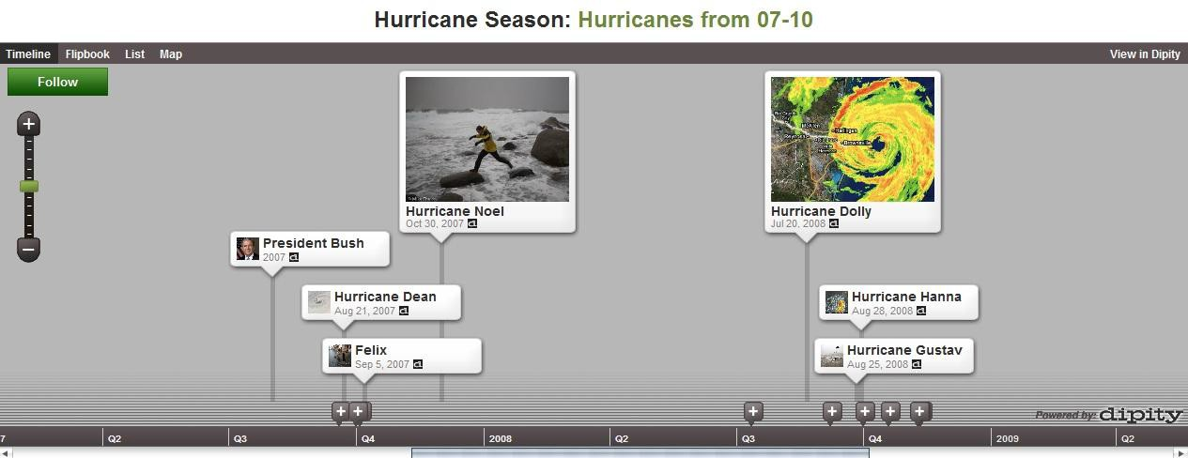An interactive timeline application using Dipity.

PART A/ Five-Paragraph Essay
Famous Trials: (have been hyperlinked to Wikipedia.org for a brief summary)

- 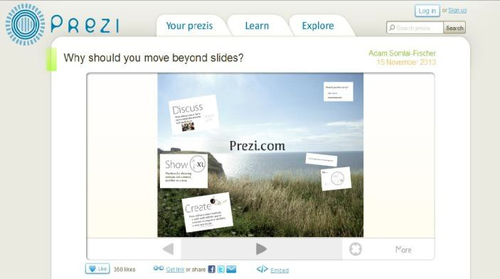Orenthal James (OJ) Simpson
(criminal trial not civil trial)
- Steven Truscott
- Lizzie Borden
- Guy Paul Morin
- David Milgaard
- Donald Marshall
- Scottsboro Boys Trial
- Watergate (Nixon)
- Dudley George
- Scott Peterson
- Kobe Bryant
- Jonbenet Ramsey
- Dr. Jack Kevorkian
- Nelson Mandela
- Salem Witch Trials
- Rodney King (LAPD officers)
- Cecil Price
- Michael Jackson
- Charles Manson
- Oscar Wilde
- Alternate trial approved by teacher

Persuasive Essay Structure: 5 Paragraphs

Introduction: Broad to Narrow

  - Broad/general statement/topic sentence (5Ws of the case)
  - Introduce the trial
  - Channel reader toward your thesis by incorporating background information
  - Thesis statement + 3 subtopics (guilty or not guilty)

Body Paragraph #1: Topic #1_
Topic Sentence + 3 points:
First. Point 1:_ Evidence 1: Analysis 1:_

Furthermore, Point 2:_ Evidence 2:_ Analysis 2:_

Finally, Point 3:_ Evidence 3:_ Analysis 3:_
Concluding Statement

Body Paragraph #2: Topic #2
Topic Sentence + 3 points:
Initially, Point 1:_ Evidence 1:_ Analysis 1:_

Not only but also, Point 2:_ Evidence 2:_ Analysis 2:_

Finally, Point 3:_ Evidence 3:_ Analysis 3:_
Concluding Statement

Body Paragraph #3: Topic #3 Topic Sentence + 3 points: To begin, Point 1:_
Evidence 1:_ Analysis 1:_

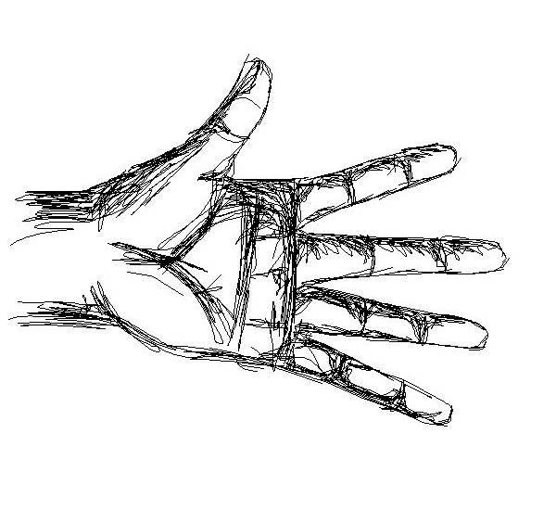

Conclusion: Narrow to Broad

    - In conclusion, paraphrase thesis statement
    - Summarize main points in essay and evidence presented
    - End with a broad/general statement/lesson to be learned by society about the issue(s) discussed
Similar to OR different from, Point 2:_ Evidence 2:_ Analysis 2:_

Finally, Point 3:_
Evidence 3:_ Analysis 3:_
Concluding Statement

Introduction: Broad to Narrow
      - Broad/general statement about the topic (5Ws of the case)
      - Introduce the trial
      - Channel reader toward your thesis by incorporating specific background information
      - Thesis statement + 3 main ideas (subtopics)

Body Paragraph #1:_ Topic Sentence (type of evidence) + 3 points: First, point 1:
Evidence 1:_ Analysis 1:

Furthermore, point 2: Evidence 2:_ Analysis 2:

Finally, point 3: Evidence 3:_ Analysis 3: Concluding Statement

Body Paragraph #2:_ Topic Sentence (type of evidence) + 3 points: First, point 1:
Evidence 1:_ Analysis 1:

Furthermore, point 2: Evidence 2:_ Analysis 2:

Finally, point 3: Evidence 3:_ Analysis 3: Concluding Statement

Body Paragraph #3:_ Topic Sentence (type of evidence) + 3 points: First, point 1: _
Evidence 1:_ Analysis 1:

Furthermore, point 2: Evidence 2:_ Analysis 2:

Finally, point 3: Evidence 3:_ Analysis 3:
Concluding Statement

Conclusion: Narrow to Broad
      - Repeat (or paraphrase) thesis statement
      - Summarize 3 main subtopics in essay, including evidence presented
      - End with a broad/general statement/lesson to be learned by society about the issue(s) discussed

Remember the Paragraph Structure…
EVERY paragraph that you write requires the following:
- An introduction sentence;
- A concluding sentence; and
- Three green peas
- Will be at LEAST FIVE-EIGHT SENTENCES! Let me explain further…
- Your TOPIC SENTENCE is your introduction sentence that is a general comment about your topic.
- Included in your TOPIC SENTENCE is a list of your THREE points that you are going to use to help prove your point/argument.
- Your CONCLUDING SENTENCE is the last sentence in your argument where you simply sum up your argument and points.
- Now, for those vegetables…you need THREE GREEN PEAS in EVERY paragraph!

Point #1

Evidence #1

Analysis #1
Point #2

Evidence #2

Analysis #2
Point #3

Evidence #3

Analysis #3

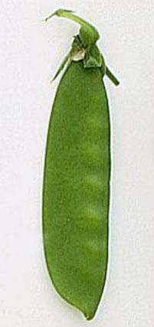

  - First, you will need to choose THREE points, and from there you need THREE pieces of evidence (or examples), and finally, you will need to have THREE analyses, which simply explain how your points prove your point.

HERE IS AN EXAMPLE:
Topic: CSI is one of the best developed shows on primetime television today.
OK, so what three points can we use to prove that CSI is one of the best TV shows?
- Three points: 1. Intricate crime scenes and forensic processes;
- Realistic characters;
- Suspenseful plots.
- These THREE points are going to prove my argument, which is that CSI is one of the best developed TV shows.

NOW, here is a sample paragraph:

Sample Written Paragraph

Topic: C.S.I. is one of the best developed shows on primetime television today.

Crime Scene Investigation is an intriguing career in our Western culture today, and because of the hype created, primetime television airs a show called CSI that explores the ins and outs of the job. The intricacies of the crime scenes and processes, the realistic characters, and the suspenseful plots make CSI one of the best developed shows on primetime television today. FIRST, the show prides itself on the details and intricacies of the crime scenes and processes of forensics. In one episode, lab tech, Hodges, tries to explore the unanswered questions of the miniature killer and discovers that bleach is
the kil l er’ s t rigger, which he found when exploring through the detailed miniature diagrams with a microscope. Particular attention to detail draws audiences in because it teaches the viewer to be more observant. NEXT, the characters are realistic in the show, which appeal to the audience because they believe the roles of each character. I n two ep is odes, CSI ’ s Stoke s a nd Sidl e were kidn a pped, a nd
a l thoug h different stra tegie s a nd kidn a ppers, the a udie nce rea l l y felt for the cha ra cters’ wel l being a nd stayed tuned for the next season to arrive when they would be found. Good character development is a large component of audience attention, and usually if characters are dynamic and real, audiences will watch. FINALLY, CSI is a suspenseful show, which appeals to audiences because they are always anticipating what may happen. In every episode there is always a twist, whether it is a piece of forensic evidence that went missing or clues lead them on the wrong path, the viewer is always in a state of suspense, which makes CSI an entertaining show to watch. Audiences enjoy suspense because it demonstrates great writing and always keeps them tuned in. In sum, CSI is one of the best developed shows on primetime television because so much attention is paid to the writing and character development.

LEGEND:
-Topic Sentence and Concluding Sentence
-Point
-Evidence
-Analysis
**Transition words are CAPITALIZED (First, Next, Finally)

WHO was involved?
Name:

K/U /14

WHERE did this occur?
WHEN did this occur?

What was the outcome?

FAMOUS TRIAL

of:
WHAT were the charges

REFERENCES

WHAT was the significance of this trial?
(websites/sources I visited to get my information)

-

-

-

-

-

Examining the Evidence

TRIAL: T/I /9 (1 mark per line + thesis)

GUILTY  Reasons or Evidence | NOT GUILTY (Reasonable Doubt) Reasons or Evidence

THESIS:

_.

Essay Organizer
BODY PARAGRAPH #1 APP /9 (1 mark per PEA)

Subtopic #1:
Point  (type of testimony or evidence presented leading toward guilt or innocence) | Examples/Evidence/Proof  (evidence or testimony presented) | Analysis  (how your example proves guilt or innocence)
1.
2.
3.

BODY PARAGRAPH #2
Subtopic #2:
Point  (type of testimony or evidence presented leading toward guilt or innocence) | Examples/Evidence/Proof  (evidence or testimony presented) | Analysis  (how your example proves guilt or innocence)
1.
2.
3.

BODY PARAGRAPH #3
Subtopic #3:
Point  (type of testimony or evidence presented leading toward guilt or innocence) | Examples/Evidence/Proof  (evidence or testimony presented) | Analysis  (how your example proves guilt or innocence)
1.
2.
3.

Peer Editing
Using the following checklist, edit a peer’s rough draft carefully using a coloured pen.

Paragraph 1:
- Are there at least 5 sentences?
- Is there a hook/question in the introduction sentence?
- Is the trial and background information included?
- Is there a thesis statement + 3 ideas/subtopics?

Paragraph 2:
- Is there an introduction sentence + 3 points?
- Are there 4 transition words (first, furthermore, finally, in conclusion)?
- Are there 3 points?
- Are there 3 examples/pieces of evidence to support guilt/innocence?
- Are there 3 sentences of analyses?
- Does the concluding sentence transition into the next paragraph?

Paragraph 3:
- Is there an introduction sentence + 3 points?
- Are there 4 transition words (first, furthermore, finally, in conclusion)?
- Are there 3 points?
- Are there 3 examples/pieces of evidence to support guilt/innocence?
- Are there 3 sentences of analyses?
- Does the concluding sentence transition into the next paragraph?

Paragraph 4:
- Is there an introduction sentence + 3 points?
- Are there 4 transition words (first, furthermore, finally, in conclusion)?
- Are there 3 points?
- Are there 3 examples/pieces of evidence to support guilt/innocence?
- Are there 3 sentences of analyses?
- Does the concluding sentence transition into the next paragraph?

Paragraph 5:
- Are there at least 5 sentences?
- Is the thesis restated differently, not just repeated?
- Are the main ideas and examples summarized?
- Is the ending sentence a general comment about being what can be learned through careful examination of the evidence in a trial, or at least something to extend the meaning outside the essay and into the real world?

Overall Comments:
- Does the essay flow well?
- Are there any spelling, grammar, or punctuation mistakes?

Final Copy
- Assessment—see rubric attached;
- Type your final copy of your essay in MLA format:
→ Last name and page number is flush right in the header (example: Jenkins 1)
→ In the upper left hand corner is the following: Your Name
Ms. Timmins
ENG 4C
Date
→ Essay title is in the center of the page after the above information and is not underlined or bolded;
→ The first sentence in every paragraph is indented one tab;
→ Your essay is double-spaced
- Submit a hard copy of your essay to me
- See examples of MLA: Model Essay Excerpt and Title

Name:

Persuasive Essay Rubric
Criteria |  | Level 1  50-59% |  |  | Level 2  60-69% |  | Level 3  70-79% |  | Level 4  80-100%
/10 Knowledge/ Understanding:  -thesis is well-developed, clear, and concise; points are logically developed-essay format: paragraphs, transitions, concluding/topic sentences  -demonstrates knowledge/understanding of the legal elements within the trial; includes textual support and reference to the case/trial  /14 Initial Trial Research |  | -thesis developed and supported in a limited way; limited development of ideas; minimal evidence of essay format  -demonstrates limited knowledge/ understanding of the legal elements  -an incomplete/non- submitted essay  -does not reflect an overall understanding of trial or evidence  -includes limited textual support |  |  | -some development evident; some support is given for thesis; some development of ideas; some evidence of formal essay format  -demonstrates some knowledge/ understanding of the legal elements  -essay reflects minimal effort  -reflects some understanding of the trial and evidence  -includes some textual support |  | -clearly developed and supported thesis; considerable development of ideas; considerable evidence of formal essay format  -demonstrates considerable knowledge/ understanding of the legal elements  -essay is complete and reflects a good understanding of the trial and evidence  -includes various textual support |  | -significantly developed and supported thesis  -thorough development of ideas; complete evidence of format essay format  -demonstrates thorough knowledge/ understanding of the legal elements  -essay is exceptional and reflects a great deal of effort  -includes significant textual support
/10 Thinking and Inquiry:  -demonstrates effective appeal to/awareness of target audience  -uses critical planning skills with attention to analysis  -demonstrates creativity and organization  /9 Evidence Chart |  | -demonstrates limited appeal to/awareness of audience  -uses critical planning skills with limited effectiveness  -uses creative elements of design with limited effectiveness |  |  | -demonstrates some appeal to/awareness of audience  -uses critical planning skills with some effectiveness  -uses creative elements of design with some effectiveness |  | -demonstrates considerable appeal to/awareness of audience  -uses critical planning skills with considerable effectiveness  -uses creative elements of design with considerable effectiveness |  | -demonstrates highly effective appeal to/awareness of audience  -uses critical planning skills with a high degree of effectiveness  -uses creative elements of design with a high degree of effectiveness
/10 Application:  -makes connections between the evidence presented and the outcome of the trial  /9 Essay Organizer |  | -makes connections with limited effectiveness |  |  | -makes connections with some effectiveness |  | -makes connections with considerable effectiveness |  | -makes connections with a high degree of effectiveness
/30  Communication:  -communicates in a clear, concise manner  -uses various forms of communication for different purposes  -uses the required language conventions (i.e., grammar, spelling, punctuation) with accuracy and effectiveness |  | -communicates information and ideas with limited clarity  -demonstrates limited command of various forms  -uses the required language conventions with limited accuracy and effectiveness |  |  | -communicates information and ideas with some clarity  -demonstrates moderate command of various forms  -uses the required language conventions with some accuracy and effectiveness |  | -communicates information and ideas with considerable clarity  -demonstrates considerable command of various forms  -uses the required language conventions with considerable accuracy and effectiveness |  | -communication information and ideas with a high degree of clarity  -demonstrates extensive command of various forms  -uses the required language conventions accurately and effectively all or almost all of the time
K/U  /24 | T/ |  | /19 | APP  /19 |  | COMM  /30 |  | TOTAL:  /92  Level: Percent: %

Comments:

PART B/ Verbal Presentation
Incorporate your evidence and argument into a five-eight minute verbal presentation, selecting one of the following
- A digital reel using an interactive slideshow application of your trial, including evidence, on the Internet, such as Prezi or VuVox, PowerPoint, etc.

OR
- 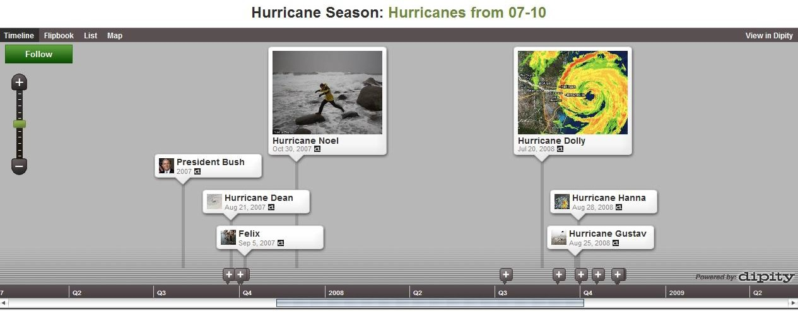An interactive timeline application of your trial, including evidence, using Dipity.

Choice of application:

Things to include in my presentation:

-5Ws (initial trial organizer)

-background information on accused

-evidence presented (types and examples)

-outcomes of the trial

-thesis argued

-did justice prevail? (offer a rationale)

Name:

Verbal Presentation Rubric
Criteria |  | Level 1  50-59% |  | Level 2  60-69% |  | Level 3  70-79% |  | Level 4  80-100%
/10 Knowledge/ Understanding:  -demonstrates knowledge/ understanding of the legal elements within the trial; understanding of trial and evidence; includes textual support and reference to the case/trial |  | -demonstrates limited knowledge/ understanding of the legal elements  -an incomplete/non- submitted essay  -does not reflect an overall understanding of trial or evidence  -includes limited textual support |  | -demonstrates some knowledge/ understanding of the legal elements  -essay reflects minimal effort  -reflects some understanding of the trial and evidence  -includes some textual support |  | -demonstrates considerable knowledge/ understanding of the legal elements  -essay is complete and reflects a good understanding of the trial and evidence  -includes various textual support |  | -demonstrates thorough knowledge/ understanding of the legal elements  -essay is exceptional and reflects a great deal of effort  -includes significant textual support
/10 Thinking and Inquiry:  -demonstrates effective appeal to/awareness of target audience  -uses critical planning skills with attention to analysis  -demonstrates creativity and organization |  | -demonstrates limited appeal to/awareness of audience  -uses critical planning skills with limited effectiveness  -uses creative elements of design with limited effectiveness |  | -demonstrates some appeal to/awareness of audience  -uses critical planning skills with some effectiveness  -uses creative elements of design with some effectiveness |  | -demonstrates considerable appeal to/awareness of audience  -uses critical planning skills with considerable effectiveness  -uses creative elements of design with considerable effectiveness |  | -demonstrates highly effective appeal to/awareness of audience  -uses critical planning skills with a high degree of effectiveness  -uses creative elements of design with a high degree of effectiveness
/10 Application:  -makes connections between the evidence presented and the outcome of the trial |  | -makes connections with limited effectiveness |  | -makes connections with some effectiveness |  | -makes connections with considerable effectiveness |  | -makes connections with a high degree of effectiveness
/10  Communication:  -communicates in a clear, concise manner  -uses various forms of communication for different purposes  -uses the required language conventions (i.e., grammar, spelling, punctuation) with accuracy and effectiveness |  | -communicates information and ideas with limited clarity  -demonstrates limited command of various forms  -uses the required language conventions with limited accuracy and effectiveness |  | -communicates information and ideas with some clarity  -demonstrates moderate command of various forms  -uses the required language conventions with some accuracy and effectiveness |  | -communicates information and ideas with considerable clarity  -demonstrates considerable command of various forms  -uses the required language conventions with considerable accuracy and effectiveness |  | -communication information and ideas with a high degree of clarity  -demonstrates extensive command of various forms  -uses the required language conventions accurately and effectively all or almost all of the time
K/U  /10 |  | T/I  /10 | AP | P  /10 | C | OMM  /10 | TOTAL:  /40  Level: Percent: %

Comments:

